Ancient Woodland Inventory Enquiry

The Ancient Woodland Inventory (AWI) categorises woodlands as Ancient Semi-natural (ASNW), Plantation on Ancient Woodland Site (PAWS), Restored Ancient Woodland Site (RAWS) or Ancient Woodland Site of Unknown category (AWSU).

If you have a query about, or contest the designation of, any woodland in the Ancient Woodland Inventory please let us know. Please complete the form below.

Your details
Name | Rebekah Bristow
Address | 58 Marine Terrace, Flat 5, Aberystwyth, SY23 2BX
Phone number | 07837836516
Email address | beb34@aber.ac.uk

Woodland area you are querying
Name of woodland (please attach a map if you can) | Frenni Fawr, Crymych SA37 0HZ  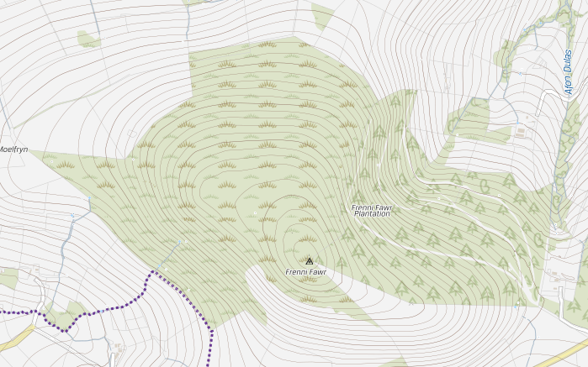
Nearest town or village | Crymych
National grid ref (eg. SN 450321 ) | SN 2029 3491
Category of woodland identified in the AWI (please indicate) ¹ | ASNW | RAWS | PAWS | AWSU

What is your query?

This query seeks to understand the reasoning for this woodlands absence on the AWI. Albeit, there may be enough evidence obtained to potentially allow for the re-categorisation of this woodland on the AWI. Attached to this formal enquiry form are some supplementary materials which may support you in your decision making.

Do you believe the woodland is wrongly categorised? Yes No

If you believe it is wrongly categorised please supply as much evidence as you can to support this: such as field survey evidence, historical evidence. Please attach separately.

Signed:  Date: 27/10/20

Please return to SFMT@naturalresourceswales.gov.uk
Natural Resources Wales, Welsh Government building, Rhodfa Padarn, Llanbadarn Fawr, Aberystwyth, Ceredigion SY23 3UR Tel: 0300 065 3000

¹ The category of woodland can be identified on the AWI on the FC map browser at http://maps.forestry.gov.uk/imf/imf.jsp?site=fcwales_ext& as follows:

- To access the AWI go to Map Layers list to the right of the map
- Open the Forestry Commission folder where you will find the Ancient Woodland Inventory 2011 listed. As the AWI map is only visible from a threshold scale of 1:70,000 please click the red cross to the right of the words Ancient Woodland Inventory.
- Click on the ‘identify’ located to the left above the map
- Click on the woodland you are querying
- To the right of the map will appear ‘Identify Results’.
- From the list below this heading the ‘CAT_NAME’ is the full description of the category – Ancient Semi Natural Woodland = ASNW

Cover Letter
Dear Sir/Madam,
I am writing to politely query the absence of this following small patch of upland oak woodland from the Ancient Woodland Inventory.
Frenni Fawr, Boncath
Lat: 51.982472
Long: -4.607278
A small amount of evidence has been accumulated which has contributed reason to believe this woodland deserves categorisation on the Acient Woodland Inventory, Wales. Attached below are photographs from past and present, supplementary field survey evidence, and historical evidence.
In light of the supportive material attached, I would kindly ask that you visit the small patch of woodland to help aid with your decision in potentially re-categorising this ‘forgotten’ woodland. Further, this woodland may be a potential area of conservation deserving statutory designation.
At present, research sampling is being discussed and liaised between willing environmentalists for this site, in order to help form a staged progression of its conservation significance and imminent threats. This is a personal effort between individuals to collate an arsenal of compelling scientific evidence which will help support that this woodland patch should be conserved and potentially managed in the future.

- Supplementary Photographs
b
a
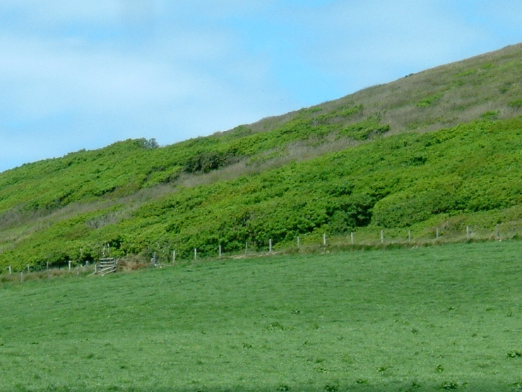
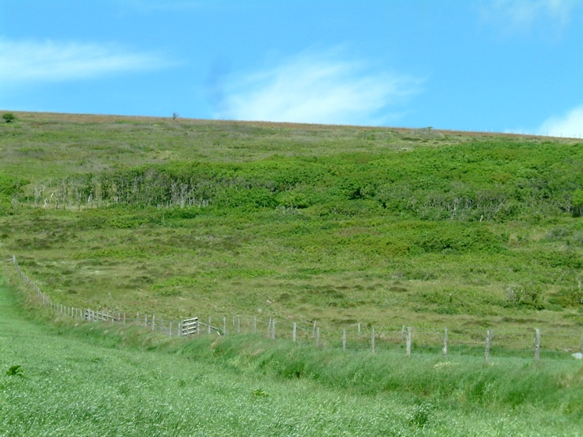
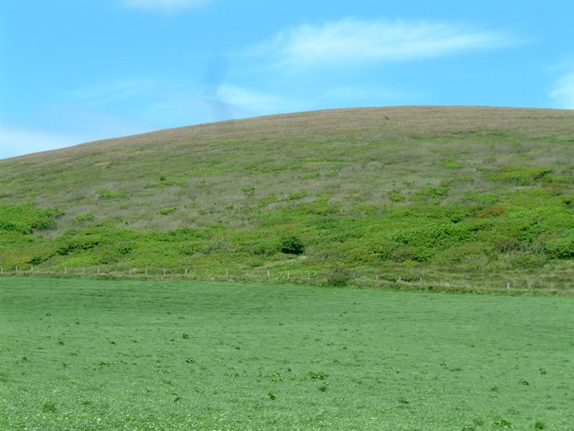

c

Figure 1. (a-c) Oak woodland patch on Frenni Fawr’s south facing slope, June 2004. Source: © Huw Denman.
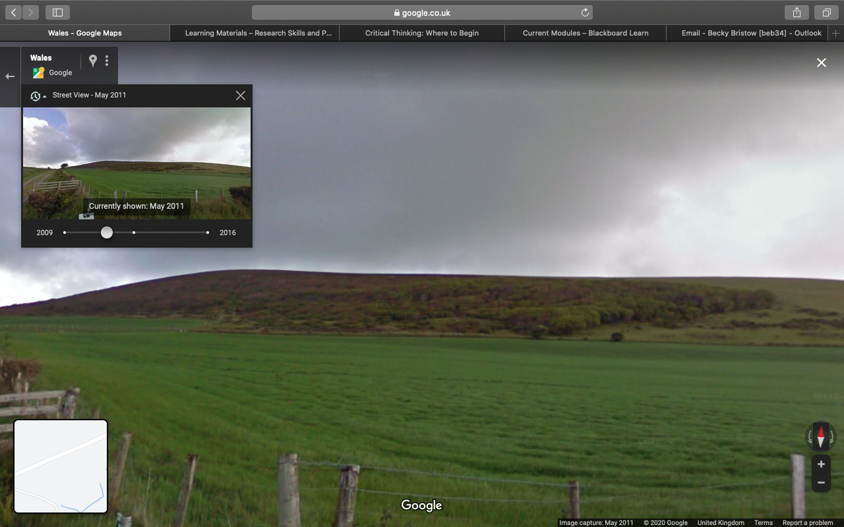
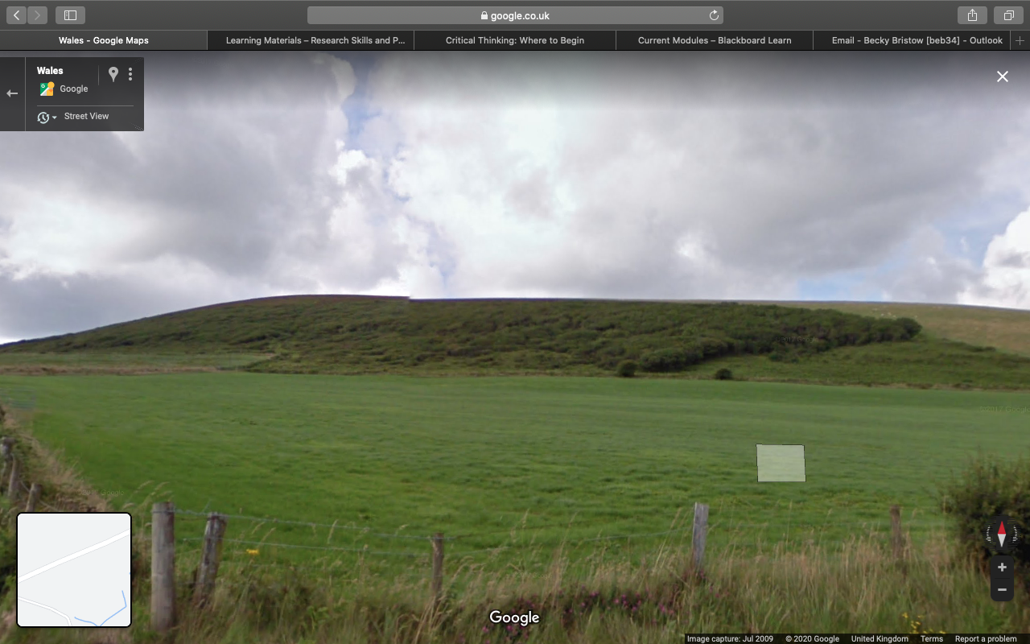
a) July 2009
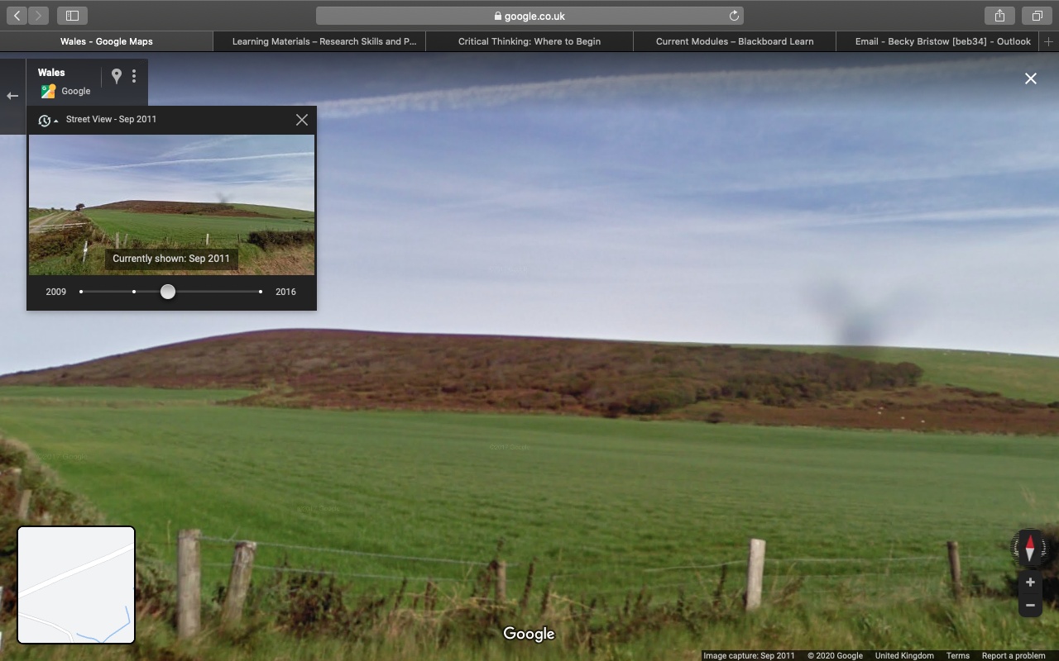
b) May 2011
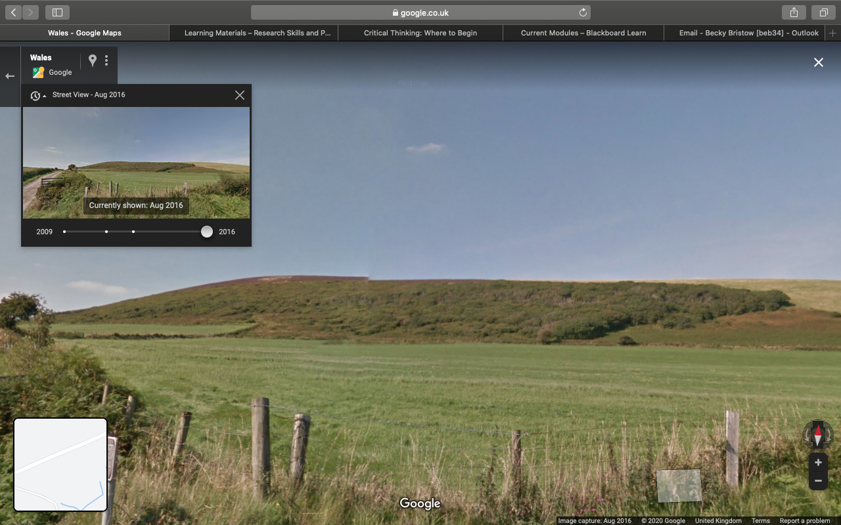
c) September 2011
d) August 2016
Figure 2. (a-d). Oak woodland patch on Frenni Fawr’s south facing slope from 2009-2016. Source: Google Maps.

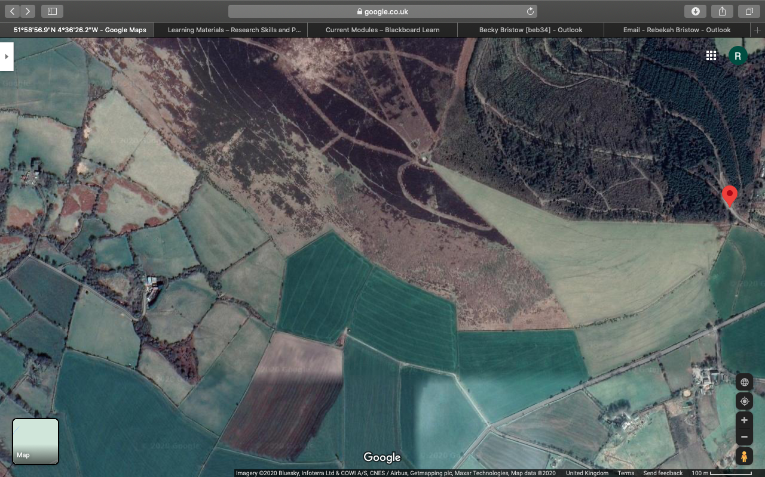
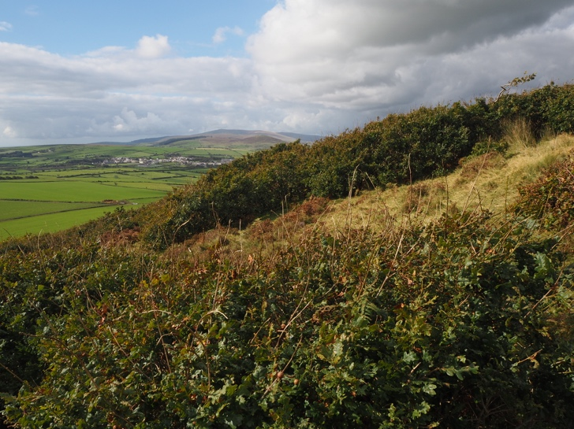
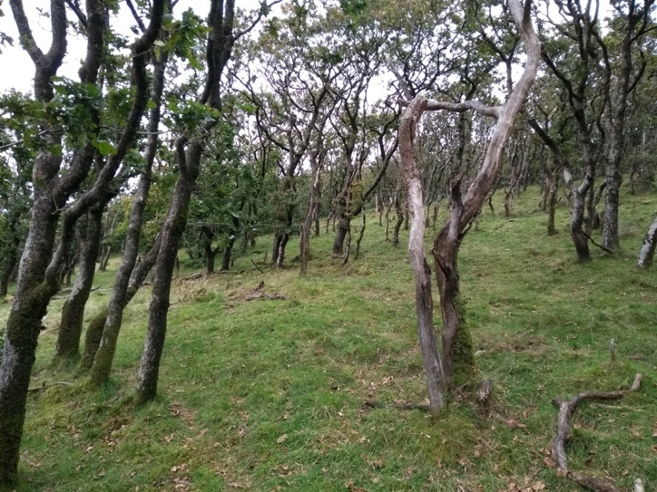
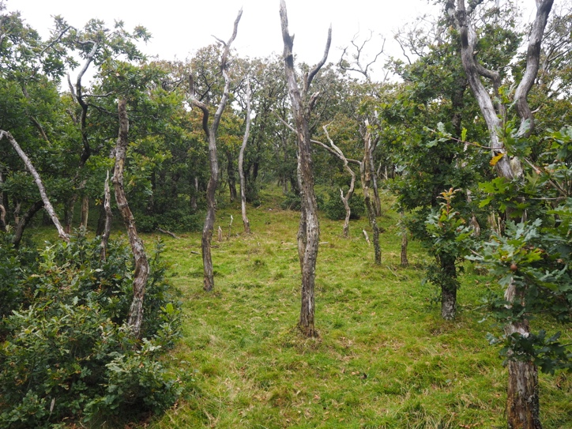
b
d
c
a

Figure 3. (a-d) September 2020. a+b) Reflect the south east area of woodland (ref. Figure 2.) Note: several specimens of standing dead wood and a small amount of fallen dead wood is present at the site c) Dense side profile of ground/low scrub oak on south facing slope. Source: a) © David Harries b/c) © Huw Denman. d) Ariel view of south facing slope with oak woodland present Source: Google Maps.
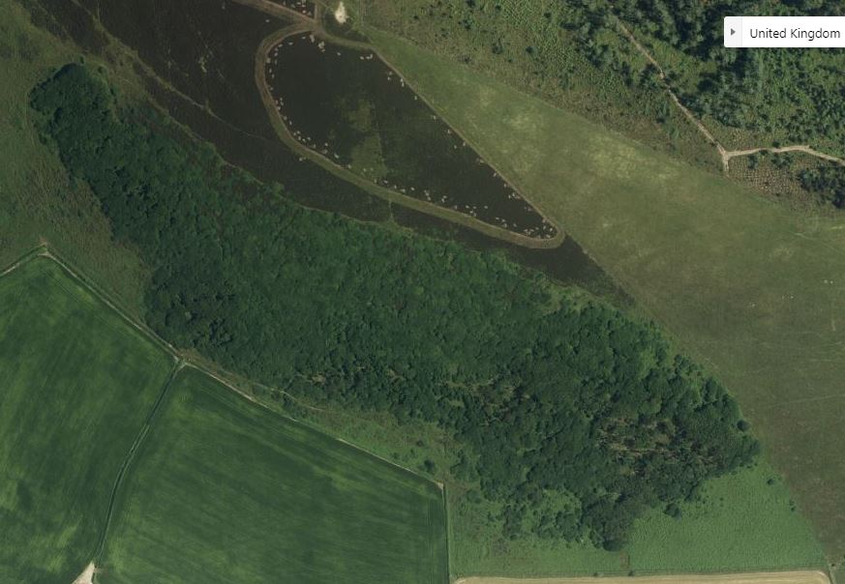
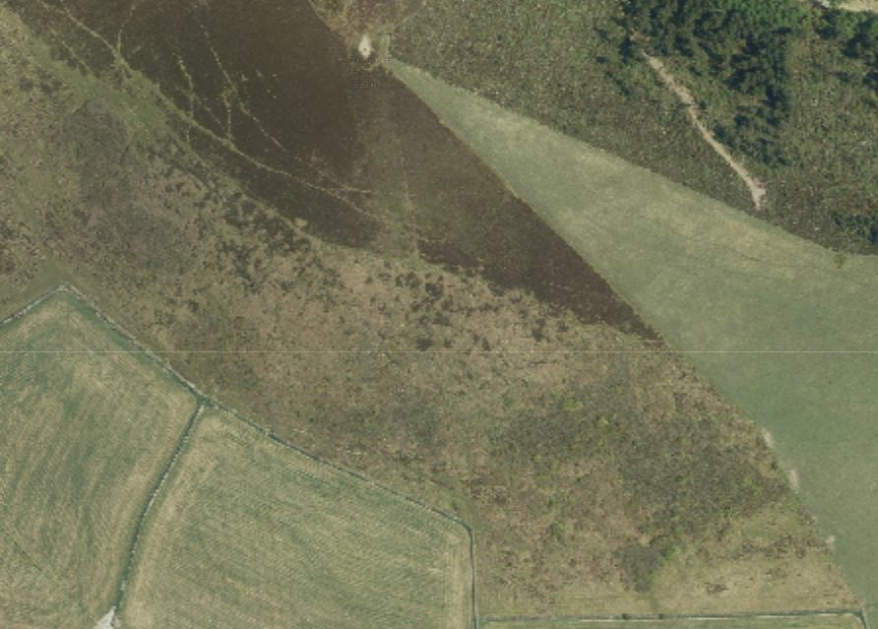

b
a

Figure 4. a) 2013 b) 2019 ariel satellite imagery of Frenni Fawr’s oak woodland. Note: Despite seasonality difference at time of imagery, the extent of the woodland has remained fairly restricted since 2013, with no obvious evidence of expansion. In the 2019 ariel image, a south east corner of outlying scrub has been lost. Source: a) http://lle.gov.wales/services/tiles/apu/#2013/leaflet b) https://www.bing.com/maps/

- Field Survey Evidence
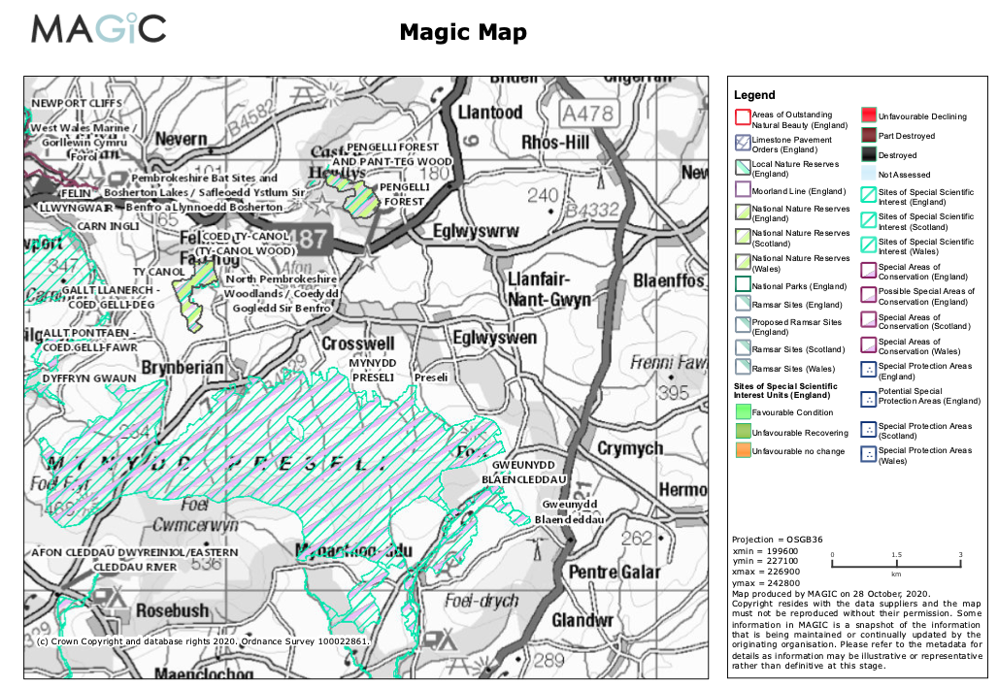
Figure 5. Magic Map data highlighting the close proximity of Frenni Fawr to existing designated sites. Mynydd Preseli (SSSI and SAC), Pengelli Forest and Pan-Teg Wood, and Coed Ty-Canol (SSSI’s).
Source: https://magic.defra.gov.uk/MagicMap.aspx

- Historic Evidence
3.1 Mapping
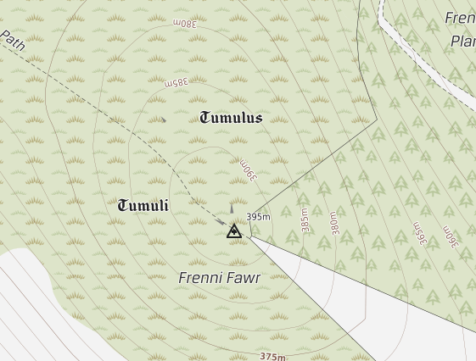
Figure 6. Historic underlay map of Frenni Fawr detailing the ‘Tumuli’ present on the hill. Source: https://magic.defra.gov.uk/MagicMap.aspx

References

